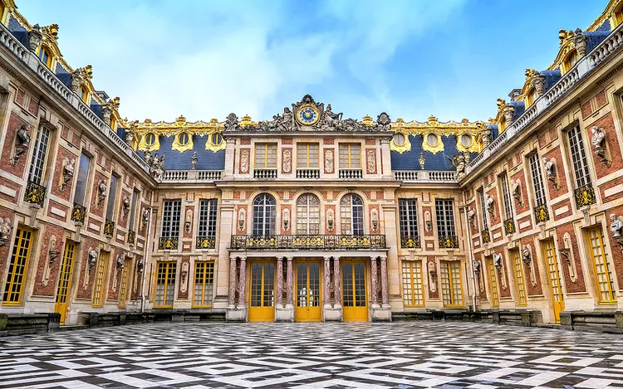

Once a humble hunting lodge, the opulent Palace of Versailles is now a magnificent testament to the lavishness of French royalty — and a symbol of the inequality that incited the French Revolution. King Louis XIV (the "Sun King" of France) transformed this rural stretch of Île-de-France into a grand palace in 1682, when he relocated the French government. Yet its role as a royal residence was short-lived. After only two more kings (Louis XV and Louis XVI), the revolution swept the nation. Versailles ceased to be a permanent palace for the French monarchy, which was done away with altogether in 1792.

Despite centuries of turmoil, the palace is now a well-preserved World Heritage Site visited by millions each year. “A visit to the Palace of Versailles is truly a walk through history, not to mention one of the most beautifully preserved palaces one can visit. While wandering through the many rooms of the palace, visitors can easily imagine the queen getting ready, the king reading a book, or guests enjoying a party in the Hall of Mirrors,” Cécile Lavarenne, head of sales for Paris at GetYourGuide, shared with*Travel + Leisure*.

Ready to see the palace in all its splendor for yourself? Here’s how to plan the perfect trip to the Palace of Versailles.

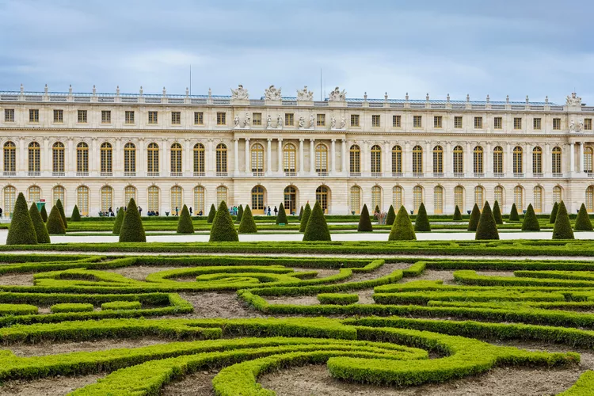 **When to Visit**

“A visit to the Palace of Versailles is the highlight for most travelers, and the best time to see it is actually in the late afternoon and closer to closing time to avoid the crowds,” Lavarenne said. “While most travelers start their visit at the palace, I’d recommend beginning in the gardens, where the symmetrical alleys, groves, and fine statues will transport you to the past.”

The palace is open to visitors Tuesday through Sunday from 9 a.m. to 5:30 p.m. It closes on some holidays, so make sure to check the website before you go. The park and gardens are open every day and are free to visit (except from April to October, when access to the gardens is ticketed from Tuesday to Sunday due to seasonal events).

**Tickets**

Tickets to the palace alone begin at €19.50 (about $21.65). Passport tickets, which include access to the palace, Estate of Trianon, and the gardens, begin at €21.50 (about $24). However, visiting the palace and the Estate of Trianon is free for visitors under 18 (or under 26 if the person resides in the European Union). Additional ticketing information and upgrades [can be found online](https://en.chateauversailles.fr/plan-your-visit/tickets-and-prices).

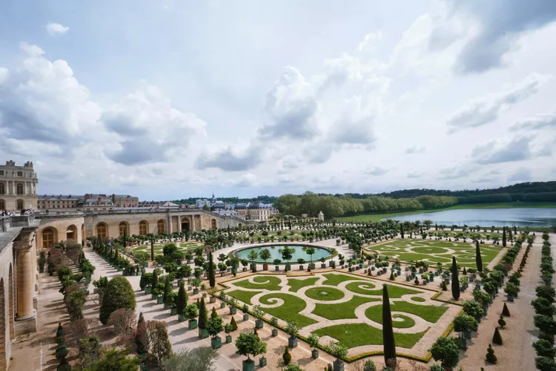

**The Hall of Mirrors**

The Hall of Mirrors was designed to replace a terrace that previously sat on the same spot. Architect Jules Hardouin-Mansart designed the updated space, which took over the terrace in 1684 and has become the most famous (and most Instagrammed) section of the palace.

**The Gardens**

Looking out from the Hall of Mirrors, guests can gaze upon the gardens created by André Le Nôtre, which took four decades to complete.

**The Estate of Trianon**

Everyone needs a little peace and quiet now and then, including the kings of Versailles, who built this secluded space just for themselves. At the Estate of Trianon, guests can visit the Grand Trianon and Petit Trianon palaces and the estate's private gardens. Here, guests can also walk through The Queen's Hamlet, built by Marie Antoinette to escape formal court life at Versailles.

**Coach Gallery**

In May 2016, a restored [collection of carriages](https://en.chateauversailles.fr/discover/estate/great-stables/gallery-coaches) was unveiled at the King's Great Stables. You can even see the carriage from Napoleon I's marriage and the small coaches that belonged to Marie Antoinette.

**Facts About Versailles**

**It's the world's largest royal domain.**

To be clear, Versailles is not the world's largest palace, but it sprawls across 2,014 acres, giving it this particular distinction. The palace itself is still a massive 721,206 square feet of space.

**French royalty hosted over-the-top parties here.**

French royalty put great effort into merrymaking, which included not only the grand balls and concerts that you would expect, but also gambling, operas, fireworks, and light shows. The grandiose performances and events were meant to impress the king's court — and all of Europe.

**Even the farm animals were (and still are) treated like royalty.**

Marie Antoinette attempted to create a version of French country village life within Versailles. You can see this at the Queen's Hamlet at Le Petit Trianon, where there's a very lucky group of cows, chickens, pigs, goats, and donkeys who have never known anything but a royal lifestyle.

**Going to sleep was a ceremonial affair.**

Kings Louis XIV, Louis XV, and Louis XVI all had courtiers attend twice-daily ceremonies in the king's bedroom. Here, they would watch him wake, as well as send him off to sleep.

**The Hall of Mirrors has seen some of European history's most significant moments.**

With several glittering chandeliers, 357 individual mirrors, and 30 tableaux that depicted the achievements of Louis XIV, the Hall of Mirrors is undoubtedly impressive. The room has also hosted many significant moments throughout history, including the signing of the Treaty of Versailles in 1919.